Introduction to Dynamic Web Content
LAB # 01



Spring 2024
CSE-403L Database Management Systems Lab

Submitted by: Ali Asghar
Registration No.: 21PWCSE2059
Class Section: C

“On my honor, as student of University of Engineering and Technology, I have neither given nor received unauthorized assistance on this academic work.”

Submitted to:
Engr. Sumayyea Salahuddin

Date:
23rd February 2024

Department of Computer Systems Engineering
University of Engineering and Technology, Peshawar
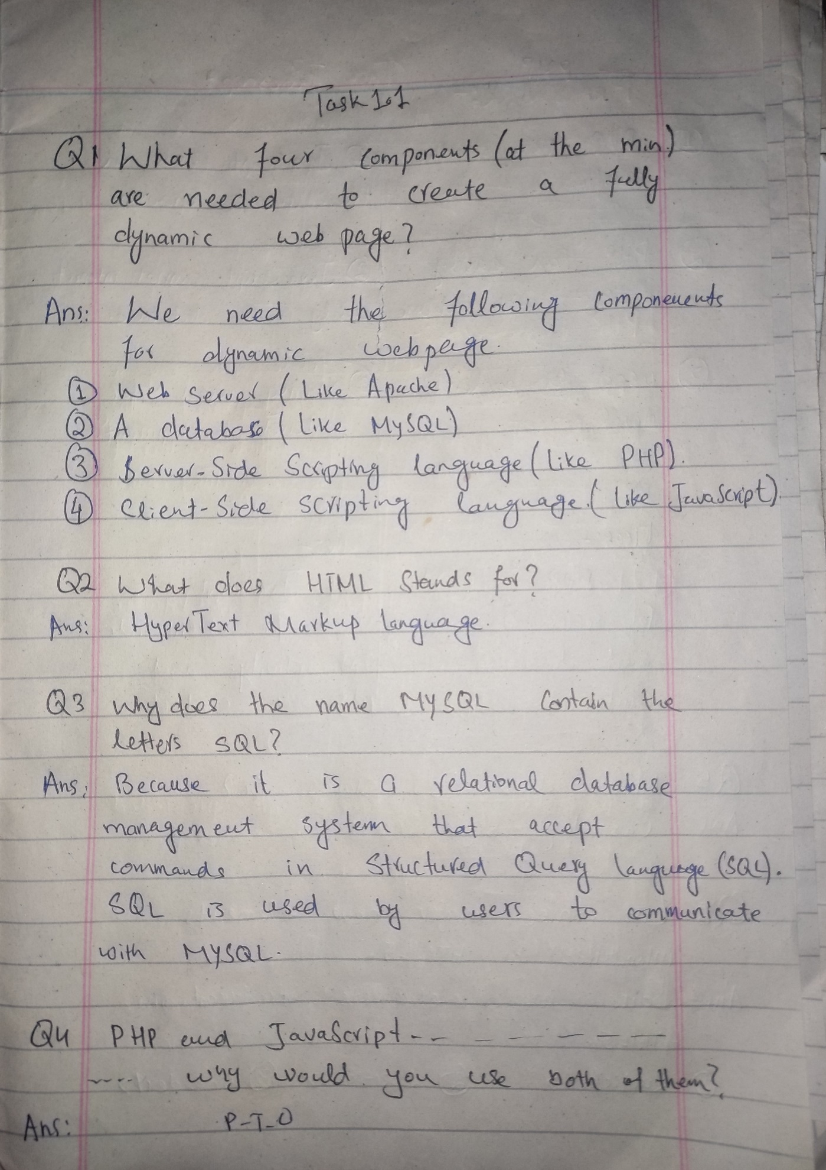
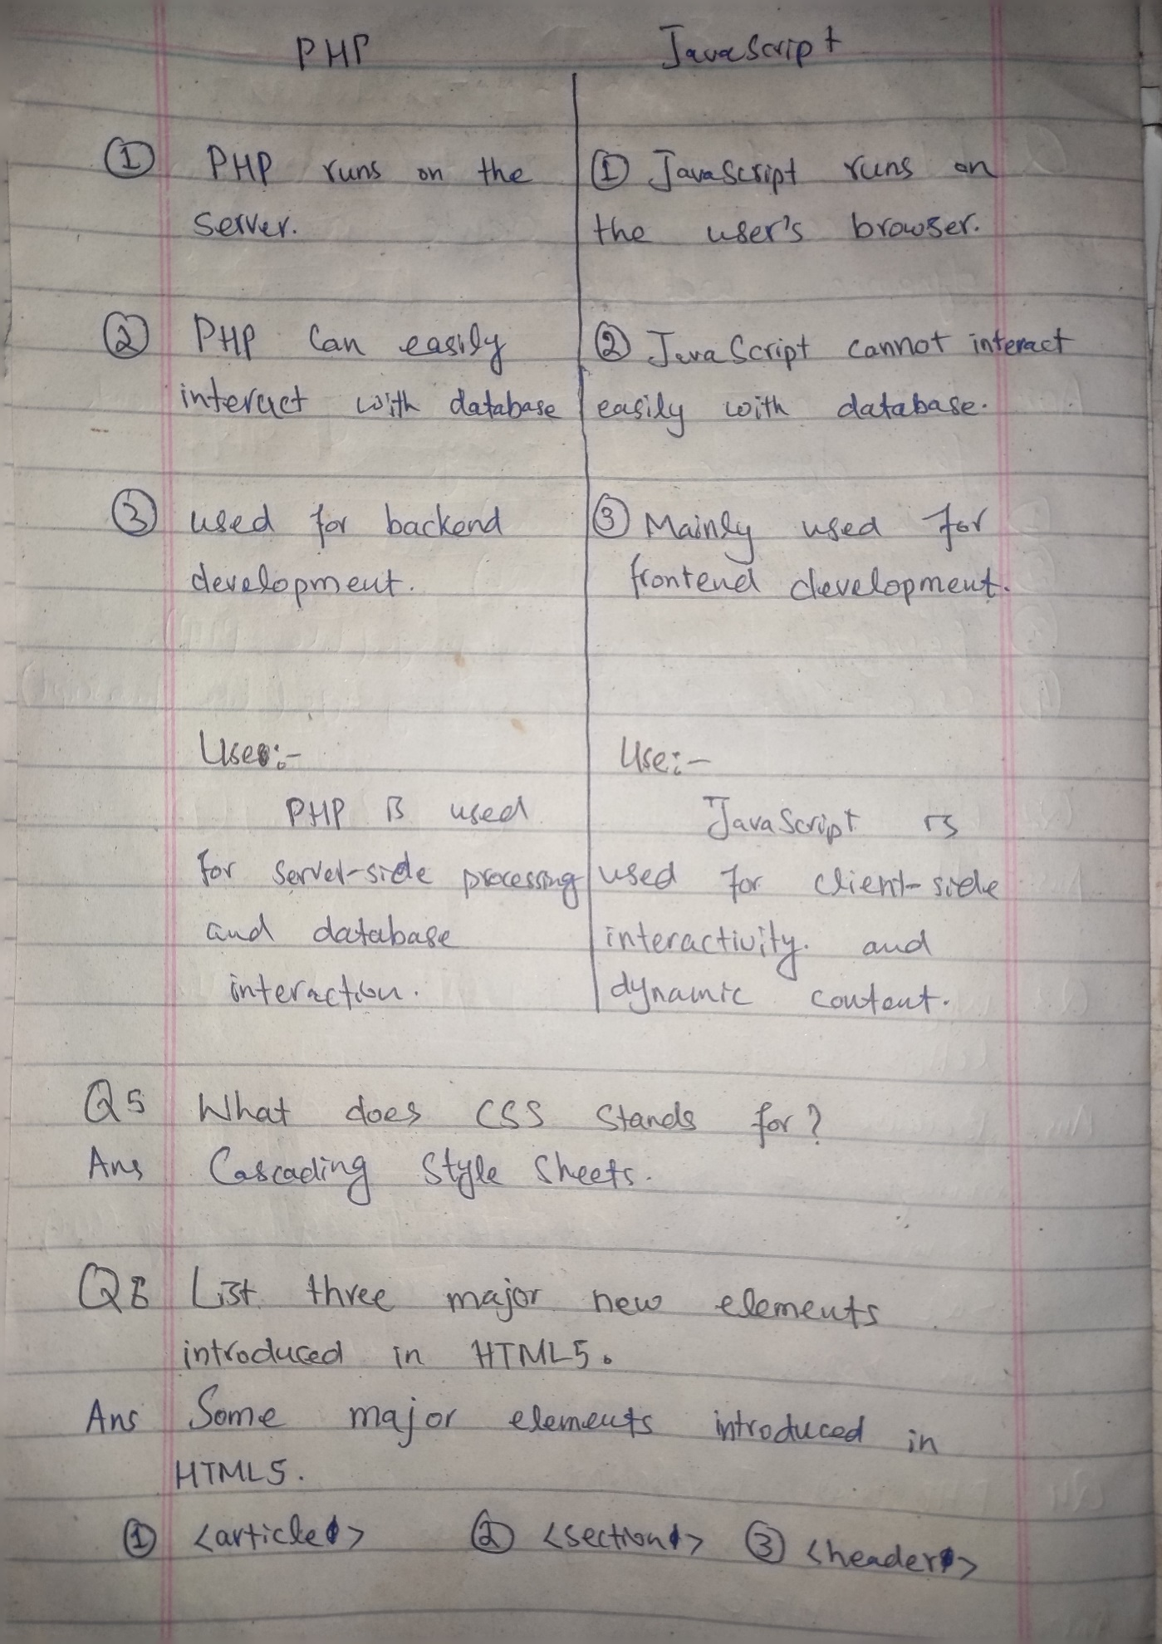
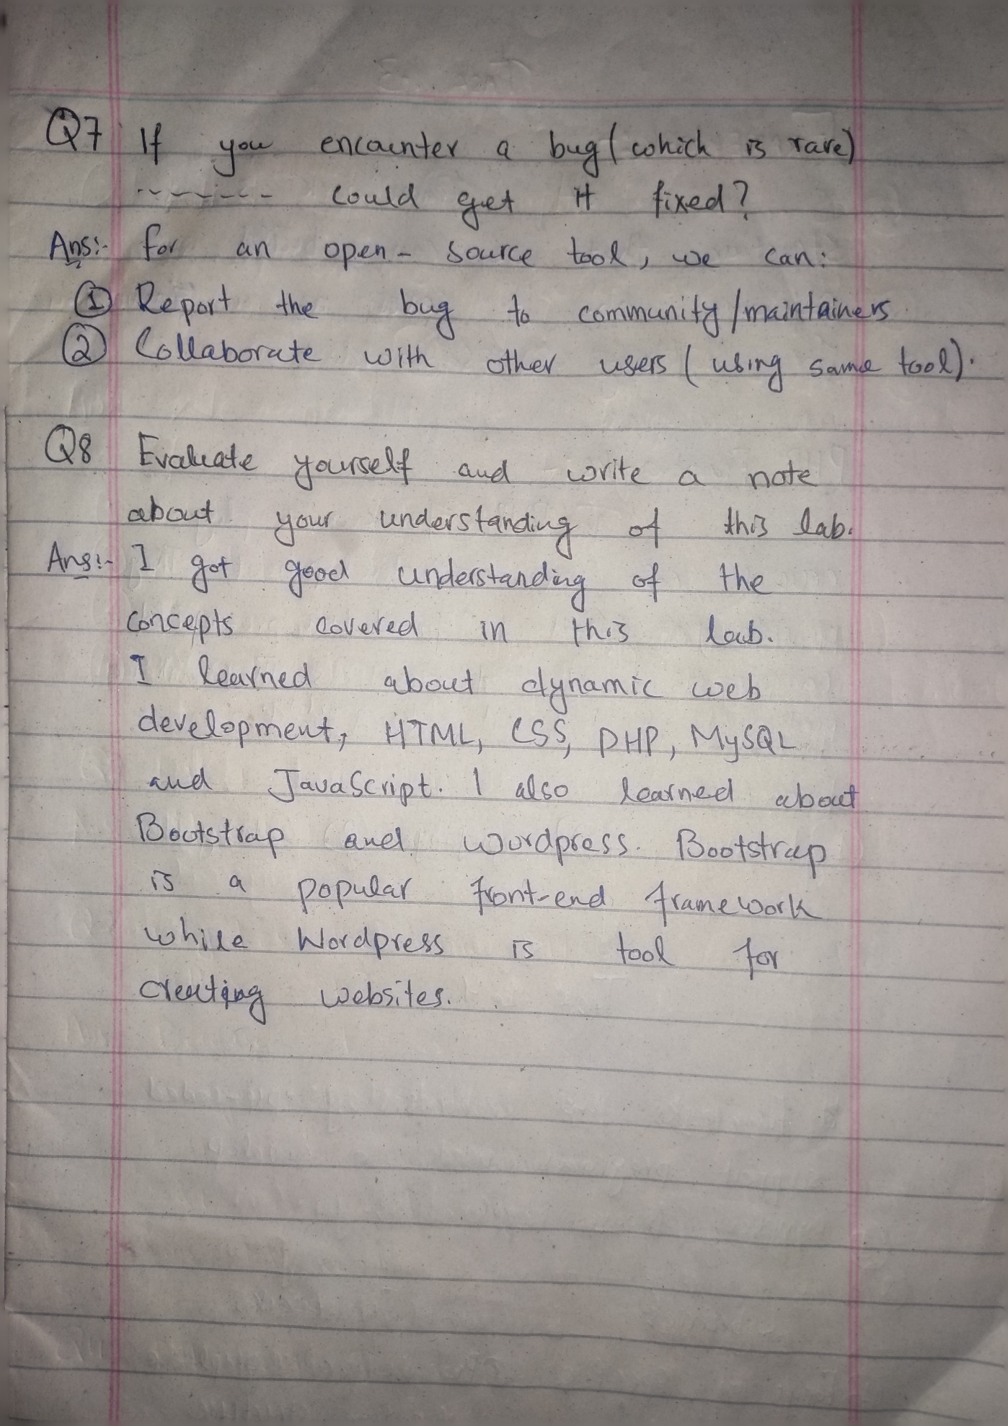
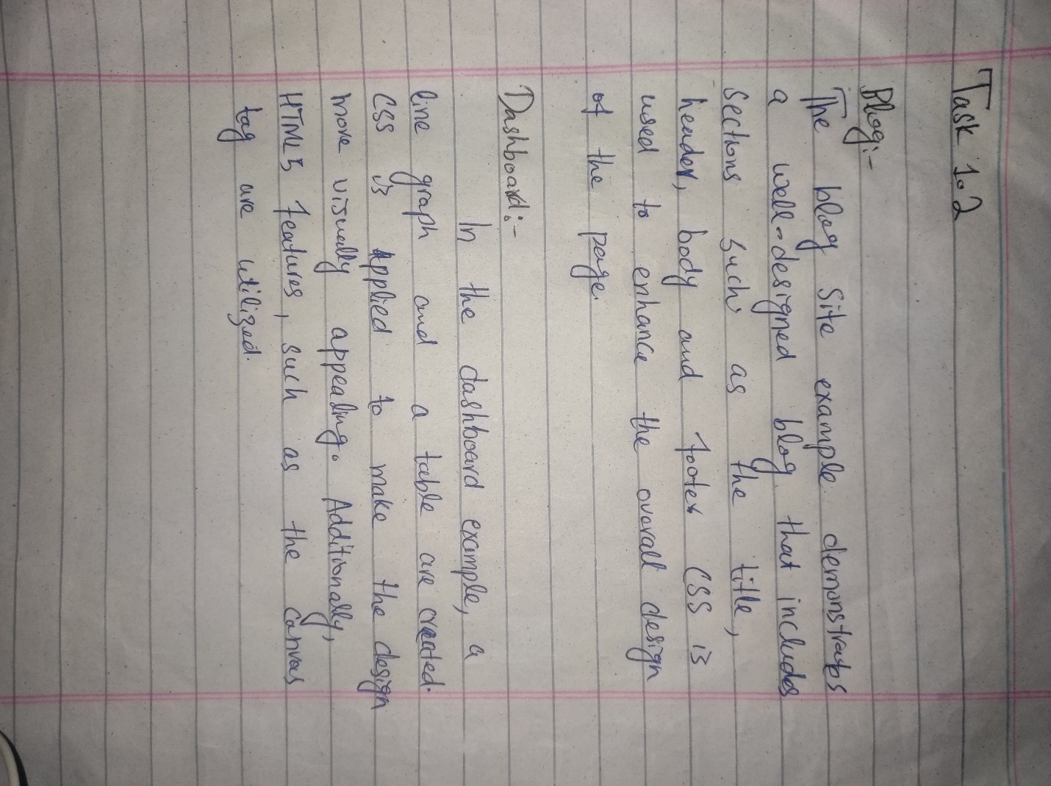
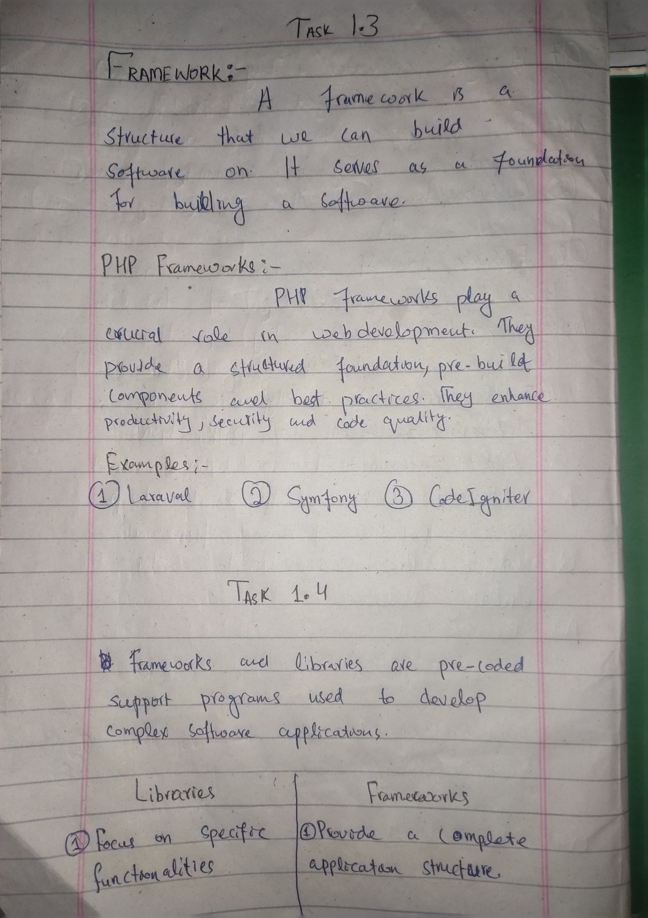
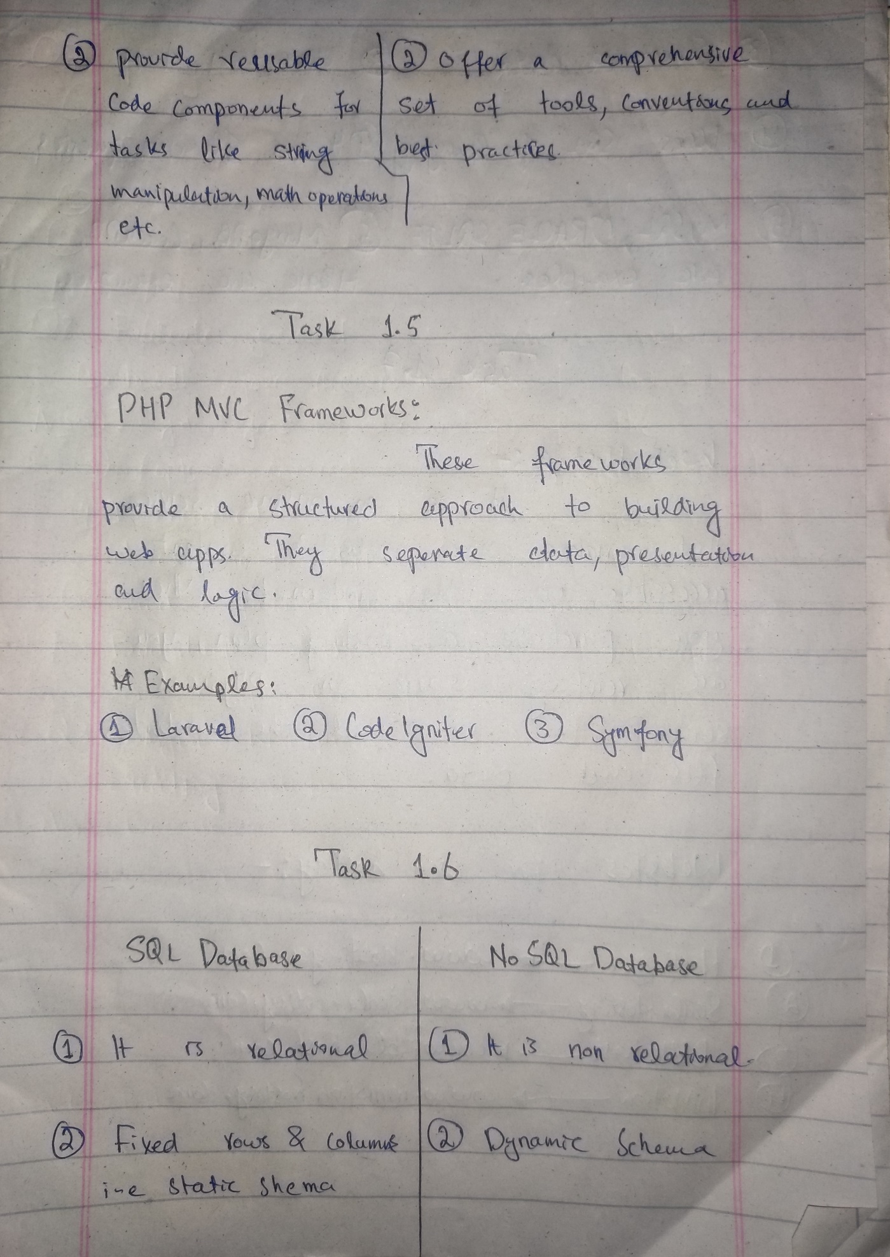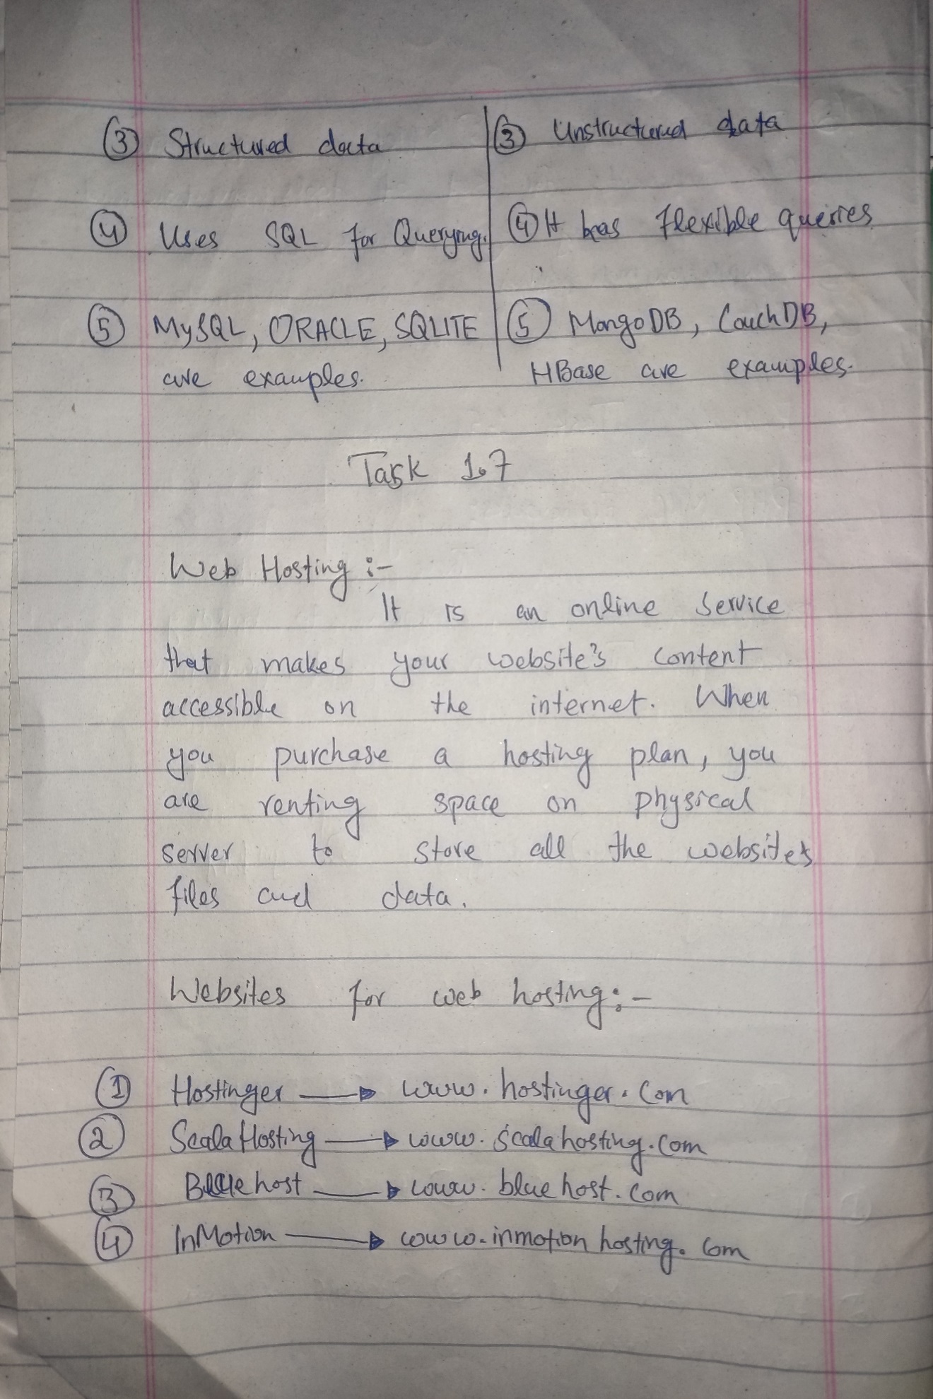
Task 8:
https://aliasghar2059.wordpress.com/

